FIOA Name: | Responsible Manager:
Area Name: | Date of Last Review: | Date of Next Review:

After hours work  Clients, Students and General Public  Computer work  Contractors, consultants, temporary staff  Electrical equipment  Manual handling | Purchasing  Smoking  Storage space  Stress  Travel and Off Campus Activities  Workplace environment and Facilities

Activity | Associated hazards/risks | Controls including relevant University and local procedures  General: University-wide arrangements  Specific: Local arrangements in place (and working) | SFARP (*) Yes/No | Current risk rating
Manual handling  Risk Rating:  Inherent = High (all) | - Application of high force  - Handling of loads which are difficult to grasp or hold  - Handling of unstable or unbalanced loads  - Poor storage practices leading to sprains and strains  - Sprains and strains from lifting, reaching, bending and twisting  - Manual handling of awkward or unstable objects including people and animals  - Frequent manual handling in awkward locations  - Handling weights over 15 kg  - Frequent handling over 5 kg  - Vibrating tools/equipment | General Controls:  - Redesign of tasks or objects  - Provision of equipment such as trolleys, shelving steps and platform ladders  - OHS Manual: manual handling and ergonomics  - Manual handling training  - Hazardous manual handling risk assessments  - Pre purchase checklists (Purchasing)  Specific Controls: |  | Medium
Measures (#)
Computer work  Risk Rating:  Inherent = High (all) | - Inadequate office furniture and equipment (chair, desk)  - Poor jobs or task design  - Inadequate lighting  - Poor keyboard and office work postures  - Repetitive keying or mouse work (overuse injuries)  - Inadequate or missed work breaks  - Poor workstation layout | General Controls:  - Task variety  - Work-breaks (10 minutes in the hour) (reminders)  - OHS Manual: manual handling and ergonomics  - Awareness of good keyboard work practices  - Workstation ergonomic assessments  - Ergonomics awareness training  Specific Controls: |  | Medium
Measures (#)
Stress  Risk Rating:  Inherent = High (all) | - Excessive workload and work demands  - Excessive multi-tasking  - Role conflict or unclear priorities  - Constant high work intensity  - Constant excessive or unreasonable client demands  - Poor feedback, lack of recognition  - Aggressive behaviour from colleagues, students, clients  - Inappropriate behaviour  - Fatigue (excessive or unsocial hours)  - Poor job or task design  - Workplace bullying and harassment  - Workplace conflict | General Controls:  - Staff training on workplace bullying, Code of Conduct and management of stress  - Manager and supervisor training and awareness (supportive management, prevention and early intervention practices)  - Local health and wellbeing program  - Awareness of Employee Assistance Program  - Code of Conduct  - OHS Manual and OHS website: Stress, Mental Health, Inappropriate Behaviours and Workplace Bullying  - Grievance Resolution Procedure  Specific Controls: |  | Medium
Measures (#)
Electrical equipment  Risk Rating:  Inherent = high (trades, workshops, laboratories)  Inherent = medium (other) | - Faulty electrical equipment causing shock or electrocution  - Use of uncertified electrical equipment/appliances | General Controls:  - Electrical Safety Standard  - Annual electrical inspections  - Tag-out, lock-out procedures  - Access permits  Specific Controls: |  | Medium
Measures (#)
Storage space | - Difficult access to material storage areas  - Falling loads due to overloading of shelves  - Inadequate amount of storage (resulting in housekeeping hazards)  - Poor storage practices leading to sprains and strains | General Controls:  - Accessible planned storage  - Workplace inspections  - Ensuring housekeeping standards are maintained  - Periodic archiving of records, exam papers etc.  Specific Controls: |  | Low
Measures (#)
Workplace environment and Facilities | - Inadequate facilities: washing facilities, drinking water, dining facilities  - Glare due to lack of adequate blinds  - Inappropriate waste management  - Inadequate lighting  - High levels of nuisance noise raising stress levels and causing distraction  - Office waste  - Poorly maintained equipment  - Thermal discomfort due to inadequate heating or cooling  - Toilets inadequate, not maintained or difficult to access  - Poor office layout creating stress, poor communication or distraction | General Controls:  - Scheduled workplace inspections  - Maintenance Request System  - Use of preferred University suppliers  - Risk assessments  Specific Controls: |  | Low
Measures (#)
Contractors, consultants, temporary staff | - Conducting work unsafely or in conflict with University procedures  - Unfamiliar with University emergency procedures  - Environmental contamination  - Unfamiliarity with University procedures and conditions leading to unsafe practices, injury and environmental contamination | General Controls:  - Trained contract managers  - Appropriate local contractor management system (procedure)  - Contractor induction and training  - Safe Work Method Statements  Specific Controls: |  | Medium
Measures (#)
Clients, Students and General Public | - Activities that adversely impact on the University environment and/or staff  - Inadvertently exposed to hazards or risks | General Controls:  - Workplace inspections  - 24 hours Security Support  - Restricted access to University buildings and property  Specific Controls: |  | Low
Measures (#)
Slips, Trips and Falls  Risk Rating:  Inherent = high (Facilities, workshops)  Inherent = medium (other) | - Poor housekeeping  - Inadequate maintenance  - Poor design  - Inadequate work practices | General Controls:  - Workplace inspections  - Hazard and near-miss reporting  - Housekeeping standards  - Preventative maintenance (Facilities)  - Outdoor lighting inspections/audits  Specific Controls: |  | Low
Measures (#)
Travel and Off Campus Activities | - Inadequate communication arrangements resulting in higher risks  - Inadequate emergency planning and arrangements  - International travel to hazardous destinations  - Lack of informed consent and knowledge of local hazards  - Remote locations where there are increased risks or poor communications  - Vehicle and travel accidents  - Unfamiliar hazardous workplaces and work locations | General Controls:  - Travel authorization process  - Checking off licenses  - Using known accommodation providers  - 24 hours Security Support  - Provision of video-conferencing alternatives  - Provision of 5-star rated vehicles  Specific Controls: |  | Low
Measures (#)
After hours work | - Reduction in emergency assistance and support  - Security of staff working alone | General Controls:  - After hours work arrangements  - 24 hours Security Support  - Restricted access to University buildings and property  - Lighting of public spaces and use of CCTV  Specific Controls: |  | Low
Measures (#)
Purchasing  Risk Rating  Inherent = medium | - See specific hazard such as Chemicals, Plant, Computer Work | General Controls:  - Pre-purchasing checklists and controls  - Preferred and approved providers  - As per specific hazard  Specific Controls:
Measures (#)
Smoking  Risk Rating  Inherent = Low | - Exposure to passive smoking increasing the risk of disease and respiratory irritation  - Waste generation from litter and butts  - Increased risk of fire | General Controls:  - Smoke free Deakin University  - No smoking in vehicles  - No smoking signs  Specific Controls:
Measures (#)
Measures (#)
Measures (#)

(*) SFARP: Risk is eliminated or reduced so far as reasonably practicable. If control measures have only been recently introduced or are under consideration, then NO is appropriate.
(#) For Medium or higher risk rating (only): How do you measure and report on the effectiveness of your control program? Choose at least one measure. Typical measures include training participation, number of risk assessments carried out, raising and discussing controls at team meetings, workplace inspections

Likelihood Descriptor | Rating |  | Consequence Descriptor | Rating
Almost certain to occur (90% probability) within the next 12 months or is imminent  Has occurred at Deakin in the last year, and is highly likely to occur again within 12 months | Very likely |  | Fatality or serious irreversible disabilities  Prosecution by authorities |  | 1
Likely to occur within the next 12 months (greater than 50% probability)  Has occurred in the in the last year at another University or similarly organisation | Likely |  | Hospitalisation  Lost time over 10 days  Improvement Notice from WorkSafe |  | 2
Could occur but not likely to occur in a given year (less than 30% probability)  Has occurred in the recent past (within 3 years) at Deakin or another University or similarly-sized organisation | Unlikely |  | Medical Treatment  Lost time up to 10 days |  | 3
May occur in exceptional circumstances (less than 1% probability)  Has occurred rarely in other industries or within higher education sector | Very Unlikely |  | First aid treatment |  | 4

Risk Rating | Fatality (1) | Serious Injury (2) | Medical Treatment (3) | First Aid (4)
Very Likely | High | High | High | Medium
Likely | High | High | Medium | Low
Unlikely | High | Medium | Low | Low
Very Unlikely | Medium | Medium | Low | Low
PROCESS
- Identify the OHS hazards and associated risks
- Consider current controls
- Assess the status of the current controls: 1..6
- Choose the relevant likelihood rating
- Assess the likely impact of the risk given the current controls
- Calculate the risk rating
- Consider the hierarchy of controls in choosing control measures to further reduce risk
- Take any further appropriate action (notifications, additional controls)

Risk Level | Action | Timeframe for implementation of corrective action
High | The activity where practical should cease immediately and not recommence until short term safety controls are implemented.  If the activity is to be continued without implementing safety controls the Chief Operating Officer’s written permission must be sought before recommencing.  If the activity is to be continued after implementing safety controls, the controls must be reviewed and approved by the relevant Dean/Divisional Head.  A notification must be made to, and advice must be sought from Health, Wellbeing and Safety Unit (Human Resources) as soon as practical |  | Immediate
Medium | The activity where practical should cease until safety controls are implemented.  If the activity is to be continued without implementing safety controls the Dean/Head of School/Divisional Head’s permission must be sought in writing before recommencing.  If the activity is to be continued after implementing safety controls, the controls must be reviewed and approved by the relevant Manager.  A notification must be made to the Health, Wellbeing and Safety Unit (Human Resources) as soon as practical. |  | Within 14 days
Low | Any further control should be implemented to reduce the risk to as low as reasonably practicable.
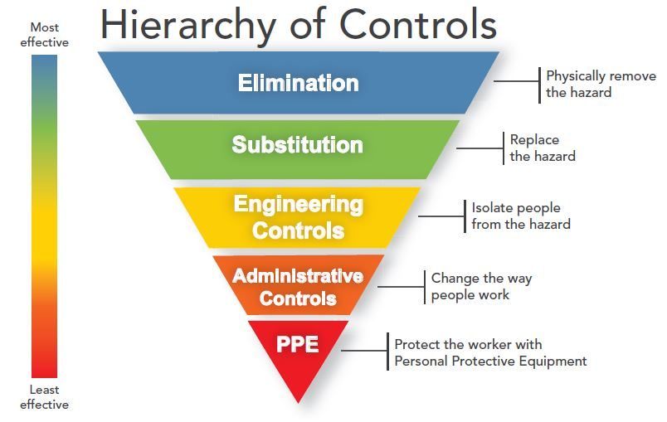
Hierarchy of hazard control
Priority | Action | Description | Example
1 | Eliminate the Hazard | Determine if the process, plant, equipment, testing methods, materials or substances are necessary | Off site fabrication,  Purchase ready to use reagents
2 | Substitute the Hazard | Reduce the risk by substituting a less hazardous process, plant, equipment, testing method, material or substance | Replace ladder with scissor lift,  Substitute solvent based paint with water based paint  Redesign plant to reduce noise levels  Replace frequent telephone use with headsets
3 | Isolate the Hazard | Isolate the hazard by using containment, shielding or distance | Put insulation around noisy equipment  Guards over moving parts
4 | Engineering Controls | Install barriers, guards, ventilation or alarms to reduce the exposure to the hazard  Minimise the size or volume of the hazard.  Rearrange the work area and work flow | Reverse alarms/lights fitted to plant  Exhaust ventilation to remove fumes  Use mechanical aids to reduce manual handling  Have deliveries made to the end-point to avoid re-handling
5 | Administrative Controls | Reduce the duration of exposure to the hazard Intersperse high demand or intense activity with lighter, less intense tasks.  Establish safe work practices  Provide training and supervision appropriate to the level of expertise of the personnel involved.  Introduce procedures, signs, permits to increase awareness of the hazard or limit exposure to the hazard.  Administrative controls may be used as a secondary measure to supplement the other agreed risk controls | Job rotation,  Work instructions,  Restricting access to the area,  Keeping the area free of clutter  Being prepared for emergencies e.g., spills  Safety inspections  Training and induction programs
6 | Personal Protective Equipment | Provide personal protection. This is the last resort because it is the least reliable and requires high levels of supervision, skills and attention.  Personal protection may be used as a secondary measure to supplement the other agreed risk controls. | Hearing protective devices,  Respirators,  Hard hats

Status | Control Status
1 | Controls are established and effective in mitigating the risk
2 | Controls are established but some improvements are possible
3 | Some controls are recently implemented and requires further development
4 | Some controls are being implemented
5 | Some controls are being tested
6 | Some controls are being considered

