Opening RMENet  In your preferred web browser, open the Deakin University page:  From the ‘Research’ menu, select ‘About Deakin Research’ (Figure 1)  Click on ‘Deakin Research Management System (DRMS) to access the staff intranet (Figure 2)  Once in the intranet site:  Click on ‘Login to RMENet’ (Figure 3)  Enter your user name and password (these are the same as the user name and password used to access the Deakin system (Figure 4) |   Figure 1 – About Deakin Research    Figure 2 – DRMS    Figure 3 – Login in to RMENet  Figure 4 – Enter user name and password
Accessing the eForm  From the ‘Projects’ drop down menu:  Select ‘My Project Request’ (Figure 5)  Click on ‘Create an RPR’ (Figure 6)  Select either:  ‘Application for ARC Grants’ (Figure 7) or  ‘Application for NHMRC Grants’  Tip: click on the blue text | 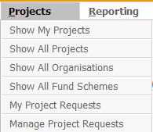  Figure 5 – My Project Requests  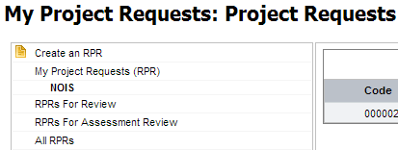  Figure 6 - Select 'Create an RPR'    Figure 7 - Click on the blue text
Instructions on using the eForm  When the form opens the first page provides instructions on how to use the eForm (Figure 8)  Instructions are also provided for each stage of the eForm, such as how to enter your NOIS details (Figure 9). |   Figure 8 – Generic instructions for using the eForm  Figure 9 - Specific instructions for each stage of the eForm
Entering the project details  In each page, complete the fields moving to the pages by clicking on the green arrow or the page name in ‘Form’ tab (Figure 10)  Tip: Expand the form tab by clicking on ‘Expand >>’ or the + in the heading box.  A green tick next to the page name indicates that all mandatory fields have been completed.  Tip: The fields marked with a red * are mandatory. The * may appear at the end of the question or just below it (Figure 11). |   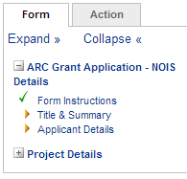  Figure 10 – Page names  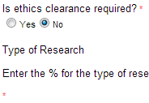  Figure 11 - Mandatory fields  Figure 8 - Saving the form
Saving the eForm  The eForm can be saved at any time by clicking on the save icon in the form icons – top right hand menu (Figure 12).  The form can be saved and closed by clicking on the folder icon and ‘OK’ to the pop up question (Figure 13). |   Figure 12 – Form Icons  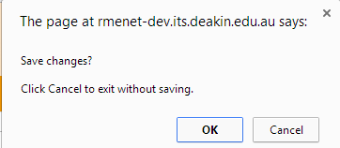  Figure 13 - Saving and closing the eForm
Actioning the eForm  When completed, go to the ‘Action’ tab on the top lhs and select either:  Submit NOIS (to send the NOIS details to the Grants Office), or  Delete NOIS (to erase the form) (Figure 14).  If any of the mandatory fields have not been completed:  An error message will appear at the top of the screen.  An exclamation mark ! will appear next to the page name where fields have not been completed.(Figure 15).  Tip: The form cannot be submitted until all mandatory fields have been completed. | 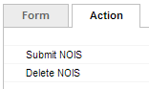  Figure 14 - Action tab  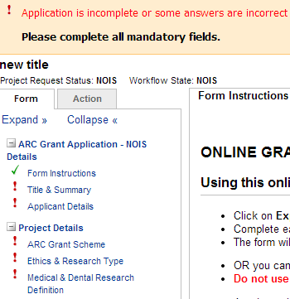  Figure 15 - Error message
Accessing the actioned eForm  The eForm can be accessed as ‘read only’ once submitted to the Grants Office.  Go to ‘My Project Requests’. The eForms will be listed in the different stages of the process (Figure 16).  Click on each stage to view the eForms in that stage.  Click on the blue title name to open the eForm (Figure 17). | 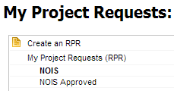  Figure 16 - eForm stages  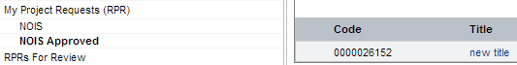  Figure 17 - list of eForms

Acronyms
RMS | Research Management System
NOIS | Notice of Intent to Submit
ARC | Australian Research Council
NHMRC | National Health & Medical Research Council
RPR | Research Project Requests

