Owner: Health, Wellbeing and Safety
Last Update: 28 October 2019

Assessor (s) | (Name, position, phone and email) |  |  | OHS Rep.
Faculty / Division |  |  |  | Date
Activity | (short description)
For Medium/High Risks below (notifications and entry on local OHS Risk Register)
Manager notified |  | Date |  | Date HWS notified
Register Name |  |  |  | Date Entered

Specific Task/Activity | What is the hazard and what harm could it cause | Inherent Risk level | Control Measures  How effective are the current controls?  What further controls are required?  How will the controls be implemented? | Final Risk level | Risk Register  Y/N

Likelihood Descriptor | Rating
Almost certain to occur/happen or is imminent, possibly frequently in a year.  There is a history of regular occurrence at Deakin. | Almost certain
Will probably occur/happen, but not a persistent issue.  There is a history in the recent past (within 3 years) of occurrence at Deakin | Likely
Likely to happen occasionally and has a reasonable chance of occurring at Deakin. | Possible
Not expected to happen, but it is a possibility in the sector | Unlikely
Very unlikely this will happen | Very Unlikely

Consequence Descriptor | Rating | Consequence Descriptor | Rating
- Single or Multiple Fatalities  - Severe injury or illness, resulting in permanent injury / disability or ill health to one or more persons  - Extreme stress and an inability to perform work duties in the foreseeable future  - Unrest / protest / violence  - Smartraveller Alert Level 4*  - Significant prosecution and fines almost certain  - Future funding / approvals / registration / licensing in jeopardy | 1  Extreme | - Injury or illness requiring medical or psychological treatment to one or more people  - Lost Time Injury (LTI) impact (less than 10 days)  - Significant stress and a noticeable reduction on ability to perform regular duties in the immediate future  - Smartraveller Alert Level 2 or combination of 2 and 3*  - Improvement Notice or Direction from WorkSafe | 3  Moderate
- Major or Multiple injuries resulting in temporary disability or ill health to one or more persons  - Significant Lost Time Injury (LTI) impact (10 days or more)  - Major stress and an inability to perform work duties in the medium to long term  - Dangerous near miss or threat  - Smartraveller Alert Level 3 or combination of 3 and 4*  - University Council / staff prosecuted without being imprisoned  - Legal / financial penalties or regulator sanctions/ attention/ reduced funding  - Prohibition Notice | 2  Major | - Minor injury, first aid treatment required. No lasting impact  - Minor concern and some reduction in ability to perform regular work duties in the short term  - Smartraveller combination of Alert Level 1 and 2*  - Voluntary compliance | 4  Minor
 |  | - No treatment required  - No concern or slight apprehension isolated to an event / situation and no impact on regular work duties.  - Smartraveller Alert Level 1* | 5  Insignificant

 | Extreme (1) | Major (2) | Moderate (3 | Minor (4) | Insignificant (5)
Almost certain | Very High | Very High | High | High | Medium
Likely | Very High | High | High | Medium | Medium
Possible | High | High | Medium | Low | Low
Unlikely | High | Medium | Low | Low | Low
Very Unlikely | Medium | Medium | Low | Low | Low

Risk Level | Priority | Action | Timeframe for implementation of corrective action
Very High | 1 | University Executive management responsibility.  Cease or isolate source of risk. Immediate attention, response and treatment required prior to commencement or continuation of work.  Requires a risk assessment and risk management plan by the relevant Executive for approval (prior to work commencing or continuing) by the Vice-Chancellor, Risk oversight by Council, Audit and Risk Committee (ARC) or nominated Committee.  The Risk must be escalated to the responsible University Executive member(s) immediately for full consideration and approval of risk mitigation/ opportunity measures with the Vice-Chancellor.  A notification must be made to, and advice must be sought from Health, Wellbeing and Safety Unit (Human Resources) as soon as practical |  | Immediate
High | 2 | Faculty General Manager/Director/Head of School management responsibility.  Cease or isolate source of risk. Immediate attention, response and treatment required prior to commencement or continuation of work.  Implementation of risk controls to be given appropriate attention, response and demonstrably managed. Executive approved risk treatment required prior to commencement or continuation of work.  Risk must be escalated to the responsible Director, Faculty General Manager or Program/ Project Manager immediately. Vice-Chancellor informed by the appropriate University Executive for consideration of risk mitigation measures to lower risk level.  A notification must be made to, and advice must be sought from Health, Wellbeing and Safety Unit (Human Resources) as soon as practical |  | Immediate
Medium | 3 | Faculty General Manager/Director/Head of School responsibility. The activity where practical should cease until safety controls are implemented.  Assess the risk, determine whether current controls are reasonably practicable for the task/ work area/ environment or if further action/ treatment is required. All risk mitigation factors to be explored and exhausted before proceeding.  If the activity is to be continued after implementing safety controls, the controls must be reviewed and approved by the relevant Manager. Monitor, review and document controls through regular business practices or local area meetings.  A notification must be made to the Health, Wellbeing and Safety Unit (Human Resources) as soon as practical. |  | Within 14 days
Low | 4 | Local Management responsibility Faculty/Portfolio/Project management responsibility. Managed by routine procedures, monitor and review as required.  Any further control should be implemented to reduce the risk to as low as reasonably practicable.
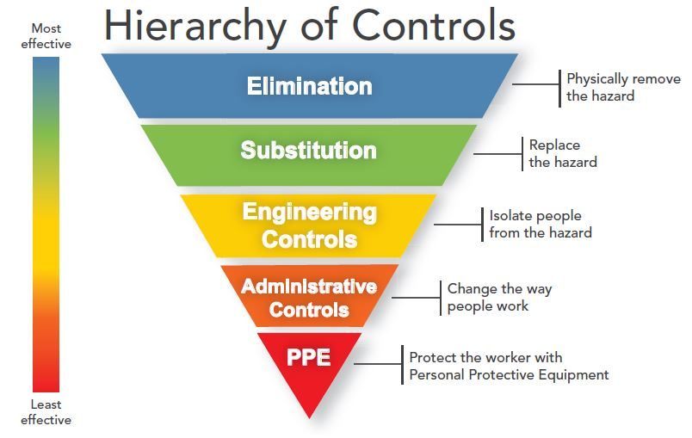
Hierarchy of hazard control
Priority | Action | Description | Example
1 | Eliminate the Hazard | Determine if the process, plant, equipment, testing methods, materials or substances are necessary | Off site fabrication,  Purchase ready to use reagents
2 | Substitute the Hazard | Reduce the risk by substituting a less hazardous process, plant, equipment, testing method, material or substance | Replace ladder with scissor lift,  Substitute solvent based paint with water based paint  Redesign plant to reduce noise levels  Replace frequent telephone use with headsets
3 | Isolate the Hazard | Isolate the hazard by using containment, shielding or distance | Put insulation around noisy equipment  Guards over moving parts
4 | Engineering Controls | Install barriers, guards, ventilation or alarms to reduce the exposure to the hazard  Minimise the size or volume of the hazard.  Rearrange the work area and work flow | Reverse alarms/lights fitted to plant  Exhaust ventilation to remove fumes  Use mechanical aids to reduce manual handling  Have deliveries made to the end-point to avoid re-handling
5 | Administrative Controls | Reduce the duration of exposure to the hazard Intersperse high demand or intense activity with lighter, less intense tasks.  Establish safe work practices  Provide training and supervision appropriate to the level of expertise of the personnel involved.  Introduce procedures, signs, permits to increase awareness of the hazard or limit exposure to the hazard.  Administrative controls may be used as a secondary measure to supplement the other agreed risk controls | Job rotation,  Work instructions,  Restricting access to the area,  Keeping the area free of clutter  Being prepared for emergencies e.g., spills  Safety inspections  Training and induction programs
6 | Personal Protective Equipment | Provide personal protection. This is the last resort because it is the least reliable and requires high levels of supervision, skills and attention.  Personal protection may be used as a secondary measure to supplement the other agreed risk controls. | Hearing protective devices,  Respirators,  Hard hats

