Chemwatch Register Compilation - Guidelines
- If you store 20 litres (or kilograms) or more of Dangerous Goods, Hazardous Substances and/or C1 combustible liquids you must have a register in Chemwatch. Each material must be listed individually in the register with the required information.

- Chemwatch will use a location based folder system
Proposed Folders | Example
Campus  Building  Level  Room  Cabinet/s | Waurn Ponds  KA  KA Level 2  KA 203.5  KA 203.5 Flammables  KA 203.5 Corrosives  Inclusion of the room number in front of the cabinet type assists for easy identification when running reports.
- Read access to everyone who has Deakin log in – Staff and Students
Read/write access will be provided only to people who manage the chemical stores in the specific area only for the stores in the specific area

- Only poisons permit holders will be able to view hidden folders for scheduled poisons. Hidden folders can also be used for proprietary chemicals.

- Please complete the register in the format provided. Please complete all mandatory sections.
If you have access to an existing register please
- Ensure it is current
- Translate to the requested format with all the requested information

- Tracie users: If your inventory is current, you may be able to run a Chemwatch download report using Tracie. Check with your area Tracie administrator.

- General household items stored and used in household quantities (generally 1 litre or less) need not be included. E.g. wash up detergent, fly spray, whiteboard cleaner, a central list will be provided for access to SDS for these materials.

- Refer to the Safety Data Sheet or container label of the material to
- identify hazardous chemicals (dangerous goods class or hazardous substances) and the
- the packaging group

- Refer to your purchasing documents, or the container label to identify the manufacturer, or your supplier.

- As far as is practicable use units of kg or litres.

- For quantities – no matter how full the container is, use the volume of the container.
Empty containers must also be included unless they are completely rinsed out of chemical are empty and have the label removed or cancelled.

Sum the total quantity of each material: For Example: Your store has 4 containers of 250g of Sodium Hydroxide the quantity of Sodium Hydroxide = 1kg

Enter current quantity = quantity usually stored and
Maximum quantity = quantity when a new order is fulfilled. I.e. the maximum likely to be stored.

- Include gas cylinders – NOTE: Quantities are as per the water capacity of the gas cylinder. See Gas Cylinder guideline below.

- What is PDF File name of SDS?
If you are providing SDS's as part of the upload request, Chemwatch uses the exact SDS filename provided to match the SDS with the material in the spreadsheet record.=
Title | Gas Cylinder Sizes and Water Capacities
Scope: | All locations where gas cylinders are stored and used.
References: | Dangerous Goods Regulations (Storage and Handling) 2012  BOC Web Page Gas Safety  AS4332 Storage and Handling of Gases in Cylinders
Why:  Risk Awareness | All gases in cylinders are considered to be hazardous chemicals and must be included in all campus store and laboratory Chemwatch Registers.  The Dangerous Goods Regulations require gas cylinder quantities entered as the water capacity of the gas cylinder/s in litres.
Direction Details: | A range of compressed gas cylinders is shown below with the approximate water capacities in kilograms or litres.  Each different gas type will require a Chemwatch Register entry.  For multiple gas cylinders of the same type simply multiply the gas cylinder volume by the number of gas cylinders of that size.  Include both full and empty gas cylinders.
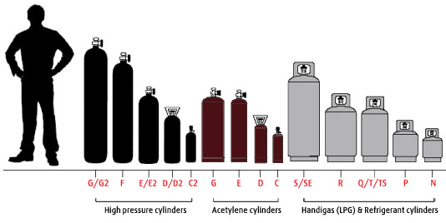
Figure 1: Courtesy of BOC Australia:
Table of Gas Cylinder Water Capacities in Litres
Size id | G/G2 | F | E/E2 | D/D2 | C2 | Acet.  G | Acet.  E | Acet.  D | Acet.  C | 90kg | S/SE  45kg | R  25kg | Q/T  18kg | FL Steel  15kg | FL Steel  36kg | P  9kg | N  5kg
Litres | 50 | 34 | 23 | 10 | 2.8 | 50 | 24 | 10 | 3 | 200 | 105 | 65 | 44 | 29.4 | 36 | 23 | 11
Height mm | 1410 | 1295 | 910 | 760 | 460 | 800 | 755 | 480 | 450 | 1340 | 1240 | 840 | 815 | 735 | 830 | 500 | 400
Linde (Air Liquide) Aligal 1 = Nitrogen; Aligal 2 = Carbon Dioxide; Alphagaz 1 = Compressed air
Contacts for further Information Sam Parry 522 73344 Anne Fisk 522 73536

