Student Name |  | Project supervisor
Contact email |  | Start date
Project Title
Project description | Outline your project aim and methodology including materials, equipment and technical resources required.
Primary Technical Officer | List the technical staff you will be working with | Lab spaces being used | List the room numbers

Specific Task/Activity  Outline each task of your project. One task per line | What is the hazard and what harm could it cause?  There could be more than one hazard per task. Examples include manual handling, crushing, cutting, puncturing, temperature extremes, ergonomic, slips trips and falls, chemical, biological, electrical, dust, noise, vibration etc. | Inherent Risk level  Refer table 1 -3 without controls in place | Control Measures  How effective are the current controls?  What further controls are required?  How will the controls be implemented?  What will you do to minimise risk of harm? | Final Risk level  Refer table 1-3 with controls in place.
Example:  Loading samples into a load frame for testing. | Risk of samples falling and hurting operator, Strain from lifting heavy objects,  Risk of pinching in load frame jaws. | Possible  Moderate MEDIUM | Use of steel cap boots and riggers gloves,  Manual handling tools such as lift trolleys, two person lift  Help loading samples to ensure safe gripping, safety features on load frame | Unlikely  Minor  LOW
Instructions can be found on page 3 |  | Refer to pages 3-4 | See table 4 for some options | Refer to pages 3-4
 |  |  | Use the tab key to add extra rows as required

Signatures:
The student/s have written the risk assessment to identify foreseeable hazards and agree to follow the control measures to ensure incidents do not occur.
Student: | X  Click or tap to enter a date. | X  Click or tap to enter a date. | X  Click or tap to enter a date.

If you are working in laboratories outside of the School of Engineering, you will need the signature of the area supervisor you will be working with.
Area Supervisor: (if using labs outside engineering) | X  Click or tap to enter a date. | Area supervisor name and position: | Area:  Choose an item. | Area supervisor notes: (any information the area supervisor would like to add)

The Technical co-ordinator/s have reviewed the risk assessment to check that foreseeable hazards have been identified and addressed adequately.
If working across multiple areas you may need more than one signature here.
Technical Coordinator/s: | X  Click or tap to enter a date. | X  Click or tap to enter a date. | X  Click or tap to enter a date.

The supervisor has reviewed the risk assessment to ensure that foreseeable hazards have been identified and addressed adequately.
Supervisor: | X  Click or tap to enter a date.

Instructions
- Think of your project and all the steps required to complete this. List these in column 1 (task/activity). One row per task.
- Now think of what could go wrong when you are carrying out this activity. Add these to column 2 (what is the hazard and what harm could it cause). There may be multiple hazards per task
- Determine the likelihood of the hazard occurring, refer table 2 for descriptors and ratings. Add the likelihood to column 3
- Determine the consequence if the hazard happened, refer table 3 for descriptors and ratings. Add the consequence to column 3
- Use table 1 to find were the two risks meet, (refer example below) and add the overall rating to column 3.
Specific Task/Activity | What is the hazard? What harm could it cause? | Inherent Risk level | Control Measures | Final Risk level
Loading samples into a load frame for testing. | Risk of samples falling and hurting user,  Strain from lifting heavy objects,  Risk of pinching in load frame jaws. | Possible  Moderate MEDIUM
Example:
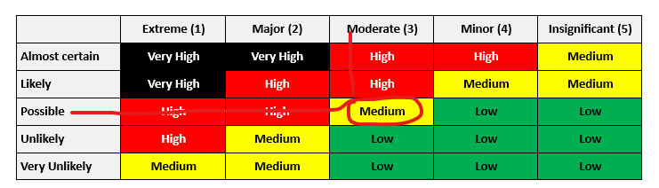
Likelihood: Possible - likely to happen occasionally and has a reasonable chance of occurring at Deakin; Consequence: Moderate – injury or illness requiring medical or psychological treatment. Where the two intersect on the table is the inherent risk level. In this case MEDIUM.
- We now think about the task and how we can reduce the risk of the task. Use table 4 to look at the hierarchy of controls. Add the control measures to column 4.
- Now reassess the likelihood, consequence and overall risk. Add these ratings to column 5.
Example:
Specific Task/Activity | What is the hazard? What harm could it cause? | Inherent Risk level | Control Measures | Final Risk level
Loading samples into a load frame for testing. | Risk of samples falling and hurting user,  Strain from lifting heavy objects,  Risk of pinching in load frame jaws. | Possible  Moderate MEDIUM | Use of steel cap boots and riggers gloves,  Manual handling tools such as lift trolleys, two-person lift  Safe gripping, safety features on load frame | Unlikely  Minor  LOW
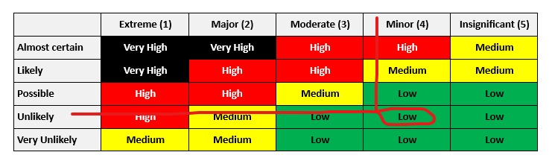
Likelihood: Unlikely - not expected to happen but could, Consequence: Minor - minor injury, first aid as we have protective protocol in place. Where the two intersect on the table is the inherent risk level. Now this is LOW.

Table 1: Overall risk rating
 | Extreme (1) | Major (2) | Moderate (3) | Minor (4) | Insignificant (5) | Take consequence from table 3
Almost certain | Very high | Very high | High | High | Medium
Likely | Very high | High | High | Medium | Medium
Possible | High | High | Medium | Low | Low
Unlikely | High | Medium | Low | Low | Low
Very unlikely | Medium | Medium | Low | Low | Low
Take likelihood from table 2

Table 2: Likelihood descriptors
Likelihood Descriptor | Rating
Almost certain to occur/happen or is imminent, possibly frequently in a year. There is a history of regular occurrence at Deakin. | Almost certain
Will probably occur/happen, but not a persistent issue. There is a history in the recent past (within 3 years) of occurrence at Deakin. | Likely
Likely to happen occasionally and has a reasonable chance of occurring at Deakin. | Possible
Not expected to happen, but it is a possibility in the sector. | Unlikely
Very unlikely this will happen. | Very Unlikely

Consequence Descriptor | Rating | Consequence Descriptor | Rating
- Single or Multiple Fatalities  - Severe injury or illness, resulting in permanent injury / disability or ill health to one or more persons  - Extreme stress and an inability to perform work duties in the foreseeable future  - Unrest / protest / violence  - Significant prosecution and fines almost certain  - Future funding / approvals / registration / licensing in jeopardy | 1  Extreme | - Injury or illness requiring medical or psychological treatment to one or more people  - Lost Time Injury (LTI) impact (less than 10 days)  - Significant stress and a noticeable reduction on ability to perform regular duties in the immediate future  - Improvement Notice or Direction from WorkSafe | 3  Moderate
- Major or Multiple injuries resulting in temporary disability or ill health to one or more persons  - Significant Lost Time Injury (LTI) impact (10 days or more)  - Major stress and an inability to perform work duties in the medium to long term  - Dangerous near miss or threat  - University Council / staff prosecuted without being imprisoned  - Legal / financial penalties or regulator sanctions/ attention/ reduced funding  - Prohibition Notice | 2  Major | - Minor injury, first aid treatment required. No lasting impact  - Minor concern and some reduction in ability to perform regular work duties in the short term  - Voluntary compliance | 4  Minor
 | 2  Major | - No treatment required  - No concern or slight apprehension isolated to an event/situation and no impact on regular work duties. | 5  Insignificant
Table 3: Consequence descriptors

Table 4: Hierarchy of hazard control
Hierarchy of hazard control
Priority | Action | Description | Example
1 | Eliminate the Hazard | Determine if the process, plant, equipment, testing methods, materials or substances are necessary | Off-site fabrication,  Purchase ready-to-use reagents
2 | Substitute the Hazard | Reduce the risk by substituting a less hazardous process, plant, equipment, testing method, material or substance | Replace ladder with scissor lift,  Substitute solvent-based paint with water-based paint  Redesign equipment to reduce noise levels  Replace frequent telephone use with headsets  Choose a less hazardous chemical
3 | Isolate the Hazard | Isolate the hazard by using containment, shielding or distance | Put insulation around noisy equipment  Guards over moving parts  Use in a fume hood
4 | Engineering Controls | Install barriers, guards, ventilation or alarms to reduce the exposure to the hazard  Minimise the size or volume of the hazard.  Rearrange the work area and workflow | Reverse alarms/lights fitted to vehicles  Exhaust ventilation to remove fumes  Use mechanical aids to reduce manual handling  Have deliveries made to the endpoint to avoid re-handling  Lifting aids
5 | Administrative Controls | Reduce the duration of exposure to the hazard Intersperse high demand or intense activity with lighter, less intense tasks.  Establish safe work practices  Provide training and supervision appropriate to the level of expertise of the personnel involved.  Introduce procedures, signs, permits to increase awareness of the hazard or limit exposure to the hazard.  Administrative controls may be used as a secondary measure to supplement the other agreed risk controls | Job rotation, help with lifting  Work instructions,  Restricting access to the area,  Keeping the area free of clutter  Being prepared for emergencies e.g., spills  Safety inspections  Training and induction programs
6 | Personal Protective Equipment | Provide personal protection. This is the last resort because it is the least reliable and requires high levels of supervision, skills and attention.  Personal protection may be used as a secondary measure to supplement the other agreed risk controls. | Hearing protective devices, Respirators, Hard hats  Gloves, Safety glasses  Enclosed or steel cap shoes

